Guidance for Theatres (RVI & FRH) - Booking and Sending Frozen Sections to Cellular Pathology

Contents

1.0 Purpose of procedure 3
2.0 Principle of Procedure 3
3.0 Personnel 4
4.0 Health & Safety 4
5.0 Summary of significant changes 5
6.0 Critical Control Point 5
6.1 Critical Control Point Table 5
7.0 Sample / Equipment / Reagents / QC 6
7.1 Sample 6
7.2 Equipment 6
7.3 Reagents 6
7.4 Internal Quality Control 6
7.5 Interlaboratory Comparison (External Quality Assurance) 6
8.0 Procedure 6
8.1 FRH Theatres During Routine Working Hours 7
8.2 RVI Theatres During Routine Working Hours 7
8.3 Out of Hours Frozen Section 8
8.4 FRH Theatres Outside of Working Hours 8
8.5 RVI Theatres Outside of Working Hours 9
9.0 Criteria relating to Procedure 9
9.1 Limitations 9
9.2 Validation 9
9.3 Verification 9
9.4 Troubleshooting 10
9.5 Biological Reference Ranges, Intervals and Clinical Decision Limits 10
9.6 Measurement Uncertainty 10
9.7 Contingency 10
10.0 References 10
10.1 Relevant Standards and Accrediting Bodies 10
10.2 Departmental and Trust policies 11
10.3 Forms 11
10.4 Related Documents 11
11.0 Appendix 1 Frozen section map- FRH routine hours 12
12.0 Appendix 2 Frozen section map- RVI routine hours 13
13.0 Appendix 3 Frozen section map- FRH out of hours 14
14.0 Appendix 4 Frozen section map- RVI out of hours 15

Guidance for Theatres (RVI & FRH) - Booking and Sending Frozen Sections to Cellular Pathology

- Purpose of procedure

    - To ensure a Frozen Section (FS) is dealt with as effectively as possible the following guidance is issued to all theatres within the RVI and FRH.
    - This guidance applies to any specimen requiring a frozen section during weekdays 8am-6pm in accordance with:

    - “Frozen Section Process Map for FRH specimens routine working hours” appendix 1

    - “Frozen Section Process Map for RVI Specimens routine working hours” appendix 2.

    - Outside of these hours, arrangements are made directly with the on-call biomedical scientist / pathologist in accordance with:

    - “Frozen Section Process Map Out of Hours for FRH Specimens” appendix 3.

    - “Frozen Section Process Map Out of Hours for RVI Specimens” appendix 4.
    - Surgeons are requested to give as much notice as possible but inevitably some specimens will arrive with almost no notice.

    - Distributed to:
      - Leazes Theatres, RVI 29008
      - Paediatric theatres, RVI 29841
      - Central Operating Theatres, FH 48333
      - ENT Theatres, FH 48675
      - Cardiothoracic Theatres, FH 48371

- Principle of Procedure

    - Following these process maps will facilitate communication between theatre and histology staff thus ensuring the procedure is completed as effectively as possible.

    - The primary contact number in histology for frozen sections is extension 29133

    - Outside of routine working hours contact on call histology biomedical scientist

    - The Histology laboratory aims to provide a verbal report for a frozen section within 30 minutes from receipt of the specimen.

- Personnel

    - All trained, competency assessed and authorised Scientific and Technical staff can perform this procedure and must comply with the conditions contained in this document. Specific tasks will be determined by competency assessment.

    - Staff in training must be supervised by a competent member of staff.

    - Equality and Diversity implications have been considered for this procedure in line with Trust policy and no restrictions have been identified. If staff feel there are extenuating circumstances hindering or preventing their ability to perform this procedure a Personal Risk Assessment must be performed by the Health and Safety Officer/Manager if one has not already been performed. This PRA will identify any modifications required to the staff member’s working practice, and/or relevant support requirements which may include (but are not limited to) additional equipment or referral to external departments such as Occupational Health.

- Health & Safety

    - Good laboratory practice is essential when performing all procedures. Staff undertaking this procedure must be aware of and operate in accordance with all current departmental and Trust Health and Safety documentation and policies.

    - All appropriate Personal Protective Equipment (PPE) must be worn at all times. The list is not exhaustive but examples would include gloves, laboratory coats and goggles.

    - All personnel performing this procedure must be familiar with current associated COSHH and Risk assessments.

    - All staff must ensure compliance with all appropriate mandatory health and safety training e.g. Infection Control.

    - All accidents and incidents must be reported in accordance with current department and Trust policies.

    - All waste must be removed in accordance with current department, Trust and Newcastle University policies and procedures as appropriate. All personnel must be familiar with these policies and procedures before performing this procedure.

    - Pathology material should be stored and retained in accordance with current department, Trust and national policies/guidelines.

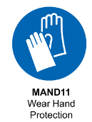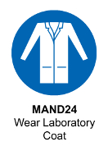

- Summary of significant changes

    - Update to format.

- Critical Control Point

    - Critical Control Points are listed in this table and referenced throughout the procedure.

  - Critical Control Point Table

Critical Control Point (CCP) reference | Critical control point | Risk | Reduction measure
 | Theatres to contact 29133 as soon as a need for a frozen section is identified | There may not be a pathologist available to provide a diagnosis unless we can plan for this | Book frozen section with Cellular Pathology as soon as practicably possible or as soon as the need is identified
 | RVI based theatres are to send specimen as soon as possible to Cellular Pathology Specimen reception | Delay in report if not delivered promptly | Send the specimen urgently to Cellular Pathology
 | FRH based theatres are to send specimen as soon as possible to Pathology Reception at FRH | Delay in report if not delivered promptly | Send the specimen urgently to Pathology reception
 | Inform 29133 when the sample is being placed in the pot | If 29133 is informed too late the hot car for collection may not be booked in time | Phone 29133 as soon as the specimen is removed from the patient and placed in the pot
- Sample / Equipment / Reagents / QC
  - Sample

    - Fresh, unfixed tissue

  - Equipment

    - Appropriate PPE
    - Assorted white propylene pots ranging in size from 500ml up to 25 litres- Genta medical supplies- 01423 358128 (HILF405)
    - Hot car transport box provided by laboratory
    - Appropriate safe transport procedures for specimen

  - Reagents

    - Not applicable to this procedure.

  - Internal Quality Control

    - Delivery of frozen sections should be performed in a timely manner in order to minimise patient time in theatre.
    - A regular audit of TAT is performed by our quality team in order to ensure compliance. Any non-conformances are addressed appropriately

  - Interlaboratory Comparison (External Quality Assurance)

    - The quality of the cryotomy and staining of tissue selected for frozen sections is assessed as part of the UKNEQAS CPT Frozen section scheme.

- Procedure

    - These instructions describe the procedure for the correct, safe and timely delivery of Frozen Sections to Cellular Pathology RVI.
    - For health and Safety reasons, suspected category 3 and above biohazard specimens cannot undergo the frozen section procedure.
    - Frozen sections may be required from FRH or RVI theatres.
    - Frozen sections may be required during routine working hours and out of normal hours
    - FRH theatres during routine working hours follow appendix 1.
    - RVI theatres during routine working hours follow appendix 2.
    - FRH theatres out of hours follow appendix 3.
    - RVI theatres out of hours follow appendix 4.

  - FRH Theatres During Routine Working Hours

    - At earliest convenience the surgeon requests or books a frozen section by contacting ext. 29133 providing (CCP6.1.1):
      - Patient details
      - Date and time of surgery
      - Clinicians name
      - Operating Theatre location/ contact number
      - Risk of infection details
    - At time of surgery telephone 29133 as soon as the specimen is placed into the pot (CCP6.1.4).
    - Send specimen in pot with histology request form to FRH Pathology reception as soon as possible (CCP6.1.3).
    - IT IS VITAL THAT THE PERSON DELIVERING THE SPECIMEN INFORMS STAFF ON RECEPTION THAT THE CASE IS AN URGENT FROZEN SECTION
    - Laboratory staff will arrange further transport of the specimen.
    - Laboratory staff will process the biopsy.
    - Histopathologist will contact surgeon with verbal report.
    - If the surgeon decides more specimens are to be sent, contact 29133 and tell the biomedical scientist as soon as the tissue is placed in the specimen pot (CCP6.1.4).
    - Send specimen in pot with a further histology request form to FRH Pathology reception as soon as possible.

  - RVI Theatres During Routine Working Hours

    - At earliest convenience the surgeon requests or books a frozen section by contacting ext. 29133 providing (CCP6.1.1):
      - Patient details
      - Date and time of surgery
      - Clinicians name
      - Operating Theatre location/ contact number
      - Risk of infection details
    - At time of surgery telephone 29133 as soon as the specimen is placed into the pot (CCP6.1.4).
    - Ensure specimen is delivered to Cellular Pathology, Level 3 NVW as soon as possible (CCP6.1.2)
    - Laboratory staff will process the biopsy.
    - Histopathologist will contact surgeon with verbal report.
    - If the surgeon decides more specimens are to be sent, contact 29133 and tell the biomedical scientist as soon as the tissue is placed in the specimen pot (CCP6.1.4).
    - Package specimen with a further histology request form and ensure they are delivered to Cellular Pathology, Level 3 NVW as soon as possible.

  - Out of Hours Frozen Section

    - The Cellular Pathology department offers an out of hours on call service for Neuropathology specimens only.
    - The Cellular Pathology department does not routinely offer an out of hours frozen section reporting service for general organs.
    - Should a frozen section be required contact the on call biomedical scientist via switchboard and seek advice on how best to proceed.

  - FRH Theatres Outside of Working Hours

    - Contact ON CALL HISTOLOGY BIOMEDICAL SCIENTIST via switchboard and discuss need for frozen section.
    - The BMS will seek advice on case from Consultant Histopathologist.
    - If Histopathologist will report case, they will contact surgeon and let them know support is to be provided.
    - If support is to be provided re-contact BMS via switchboard and provide:
      - Patient details
      - Specimen type
      - Theatre location
      - Contact telephone number
      - Time of surgery
    - Ask BMS for their contact number to prevent having to go through switch for communications.
    - Place specimen in pot, ensure specimen pot and paperwork are fully labelled and immediately book transport of specimen via Northumbria blood bikes voluntary service: Call 0191 2286495.
    - Inform that this is an emergency collection to pick up from FRH main reception and deliver to RVI Leazes reception.
    - If a blood bike is unavailable:
      - Book taxi by calling 31818
      - Provide appropriate details
      - Arrange for urgent collection of specimen from FRH Main Reception and delivery to RVI, Leazes Wing Reception.
    - Once transport has been arranged:
      - Package specimen in frozen section transport box.
      - Label transport box with:
        - FAO: Histology on call technician
        - Leazes reception, RVI
        - “Please keep at Leazes reception for histology on call BMS to collect”
    - Take package to FRH Main reception and hand over to blood bike or taxi driver.
    - Contact Histology BMS to inform that the specimen is en route.

  - RVI Theatres Outside of Working Hours

    - Contact ON CALL HISTOLOGY BIOMEDICAL SCIENTIST via switchboard and discuss need for frozen section.
    - The BMS will seek advice on case from Consultant Histopathologist.
    - If Histopathologist will report case they will contact surgeon and let them know support is to be provided.
    - If support is to be provided re-contact BMS via switchboard and provide:
      - Patient details
      - Specimen type
      - Theatre location
      - Contact telephone number
      - Time of surgery
    - Ask BMS for their contact number to prevent having to go through switch for communications.
    - As soon as specimen is placed in pot inform on call histology BMS.
    - Send specimen direct to Cellular Pathology, Level 3, New Victoria Wing.

- Criteria relating to Procedure

  - Limitations

    - Suspected category 3 and above biohazard specimens cannot undergo the frozen section procedure for health and safety reasons.
    - Cellular Pathology does not routinely provide an out of hours on call service. Essential frozen sections can be discussed with BMS and Histopathologists on a case by case basis.
    - It is up to frozen section requesting theatres to ensure all documentation is complete prior to sending specimens. Failure to provide complete information may result in delay to service.
    - It is up to frozen section requesting theatres to ensure the guidelines and process maps are followed as best as possible. Failure to follow these instructions may result in delay to service.

  - Validation

    - Not applicable to this procedure.

  - Verification

    - Not applicable to this procedure.

  - Troubleshooting

    - Specimens for intra-operative frozen section must be dealt with as quickly as possible. If there any delays please notify the person on the frozen section dect phone (ext. 29133).
    - Any issues relating to the delivery of the frozen section should be brought up in the first instance with a senior/ advanced biomedical scientist.

  - Biological Reference Ranges, Intervals and Clinical Decision Limits

    - Not applicable to this procedure.

  - Measurement Uncertainty

    - Measurement uncertainty (MU) of the assay is assessed regularly, according to the Departmental Measurement Uncertainty Guide located in Q-Pulse, with the “data stored in the Department Shared Drive/information stored on Q-Pulse* (delete as required). The data can be made available to users on request.

  - Contingency

    - If dect telephone system goes down please use ext. 24565 as main telephone number instead of 29133
    - Should hot car courier system be unavailable ordering taxi will be reinstated. Book taxi by:
      - Calling 31818
      - Leaving appropriate details
      - Give clear instructions as to where taxi driver should go to collect and drop specimen off

- References

    - None

  - Relevant Standards and Accrediting Bodies

    - The laboratory complies with all legislative requirements for practice and is assessed appropriately by external bodies such as United Kingdom Accreditation Service (UKAS), the Human Tissue Authority (HTA), Medicines and Health Regulatory Agency (MHRA) and the Home Office for evidence of conformity.

    - For the full UKAS accredited scope of tests, assessed for conformance to ISO 15189 standards please refer to the UKAS website. A link to this is available through the Laboratory Medicine website.

  - Departmental and Trust policies

    - Trust sample acceptance and rejection policy
    - Trust specimen transport policy

  - Forms

    - HILF136 Histopathology request form

  - Related Documents

    - None

- Appendix 1 Frozen section map- FRH routine hours

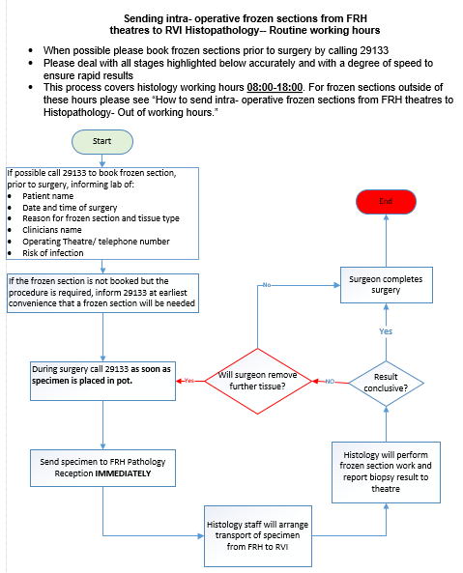

  - Appendix 2 Frozen section map- RVI routine hours

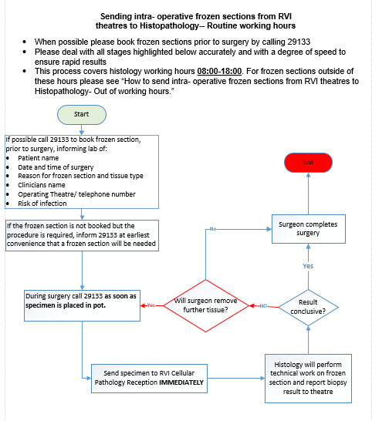

- Appendix 3 Frozen section map- FRH out of hours
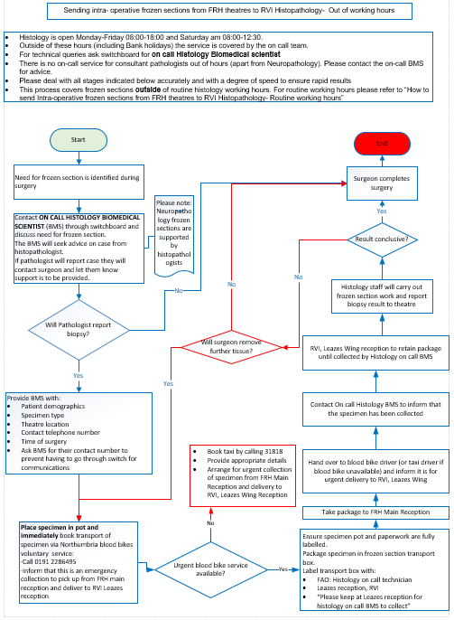

- Appendix 4 Frozen section map- RVI out of hours
